**Exercise 6 – Fourier Transform of Images (11.December.2017 16h-17h)**

1. Calculate the Fourier Transform of the image.
   * 1. X=double(imread(‘Rose.png’));
     2. Yoriginal=fftshift(fft2(X));
     3. imshow(Yoriginal,[0 255])
2. Perform the inverse Fourier Transform in the transformed image: original, center and periphery (as shown in the image below).
   * 1. Yper=Yoriginal;
     2. Yper(160:175,100:140)=0;
     3. Ycen=Yoriginal-Yper;
     4. Xcen=ifft2(ifftshift(Ycen));
     5. Xper=ifft2(ifftshift(Yper));
     6. Xoriginal=ifft2(ifftshift(Yoriginal));

? ? ?

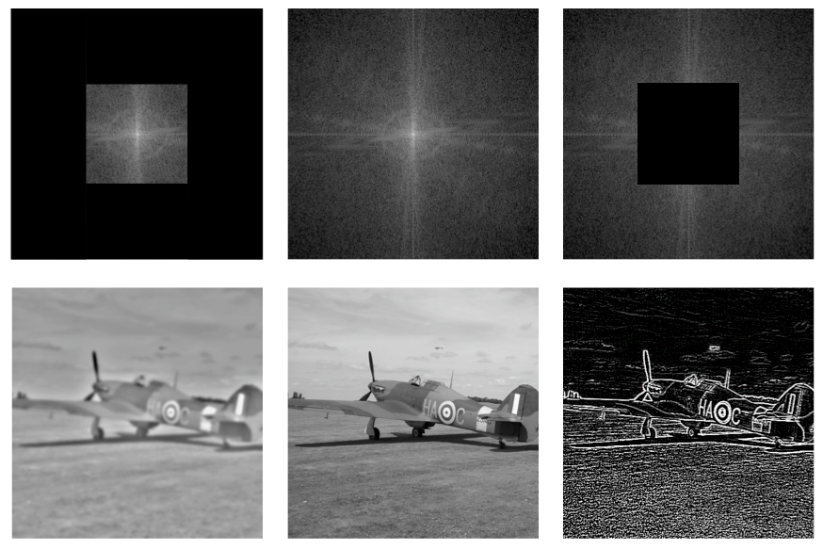

|  |  |
| --- | --- |
| ? | ? |
| Rose_center.png | Rose_periphery.png |

c) Create a Fourier space (256x256) that is all zeros, except for one point (pixel) and perform the inverse Fourier Transform. Try this in different pixels. What can you see in those images?